 

**Industrial Training Report**

**Course:** Industrial Training I

**Course code:** ICE-496

**Training subject:** CCNA

**Submitted to**

Md. Mushfiqul Islam

Lecturer, Department of Information and Communication Engineering

Daffodil International University

**Submitted by**

Name: Mahfuza Akter

ID: 201-50-023

Department of Information and Communication Engineering

Faculty of Engineering

**Acknowledgment**

I would like to express my sincere gratitude to Atova a trusted and renowned academy for CCNA,

for allowing me to undergo CCNA training. I am thankful to all the trainers and mentors who guided and supported me throughout this training.

I would like to thanks my training incharge Md Nasir Uddin sir for guiding me at the time of training

and boosting up required knowledge for training time to time.

**Abstract**

This industrial training report outlines my experience and learning during the CCNA Training Program at Atova. The training equipped me with the essential skills and knowledge required for a career as a network engineer. The report highlights the skills I acquired, the organizational profile, details of the training program, my achievements, and the outcomes, and concludes with a reflection on my overall experience.

**List of Learning**

During the industrial training program, I acquired the following key learning points:

1. Understanding networking fundamentals, including the OSI model and TCP/IP protocol suite.
2. Learn about IPV4 sub-netting, VLSM,pre-fix network
3. Configuring and troubleshooting LANs and WANs using Cisco routers and switches.
4. Port security
5. Configure SSH on Cisco IOS or Cisco Switch
6. Implementing VLANs, STP, and EtherChannel for network segmentation and redundancy.
7. Configuring and securing wireless networks using Cisco Wireless LAN Controllers.
8. HSRP
9. Troubleshooting common network issues using appropriate diagnostic tool
10. Understanding and configuring dynamic routing protocols such as RIP.
11. Implementing network services such as DHCP and DNS.
12. Configuring and securing remote access using Virtual Private Networks (VPNs) VTP mode.
13. Routing Static routing

**Skill Featured**

The industrial training program in CCNA helped me develop the following essential skills:

1. Networking knowledge: I gained a comprehensive understanding of networking concepts, protocols, and technologies.
2. Configuration and troubleshooting: I acquired hands-on experience in configuring and troubleshooting Cisco routers, switches, and wireless controllers.
3. Problem-solving: Through practical exercises and troubleshooting scenarios, I developed critical thinking and problem-solving skills to identify and resolve network issues.
4. Communication: Collaborating with fellow trainees and working on group projects enhanced my communication and teamwork skills.
5. Time management: Balancing theoretical learning and practical exercises within the given timeframe improved my time management abilities.

**Organizational Profile**

Atova Technology institute is an educational institution that offers a range of training programs and courses focused on various aspects of technology, including network administration, cybersecurity, digital marketing, software development and more. Our institutes aim to prepare students for a successful career in the tech industry by providing them with a comprehensive education that includes both theoretical and practical knowledge.

IT has Pearson & PSI vendor exam center authorization where individuals can take certification exams offered by specific technology vendors. These exams are designed to test the individual's knowledge and skills related to a specific technology or product offered by the vendor.

Vendor exams are important for individuals seeking to enhance their skills and knowledge in a specific technology or product, as well as for professionals who want to demonstrate their expertise to potential employers or clients. By passing a vendor exam, individuals can earn a certification that validates their skills and knowledge in a specific area of technology.

Their vendor exam center provides a controlled environment where individuals can take their exams without distractions or interruptions. The exam center typically has a set of rules and regulations that must be followed, such as not bringing any unauthorized materials into the testing area and following a specific dress code.



**Details of training**

Training Methodology: The training program involved a combination of theoretical knowledge and hands-on practical exercises. I attended interactive lectures, participated in lab sessions, and worked on real-world networking projects under the guidance of experienced trainers. The training curriculum followed the CCNA syllabus and included comprehensive study materials and resources.

**Achievement**

During the training program, I accomplished the following achievements:

1. Successfully configured and established a functional LAN using Cisco switches and routers, demonstrating my understanding of network design principles.
2. Implemented VLANs and inter-VLAN routing, allowing for efficient network segmentation and traffic management.
3. Configured secure wireless networks using Cisco Wireless LAN Controllers, ensuring reliable and protected wireless connectivity.
4. Successfully configured and tested network services such as DHCP and DNS, enabling efficient network resource allocation and name resolution.
5. Implemented secure remote access using VPNs, allowing for secure connectivity to the network from remote locations.

**Outcome**

As a result of the industrial training in CCNA, I have gained the following outcomes:

1. In-depth knowledge of networking principles and technologies.
2. Hands-on experience in configuring and troubleshooting Cisco networking devices.
3. Enhanced problem-solving skills to diagnose and resolve network issues.
4. Familiarity with network monitoring and management tools

.

1. Improved understanding of network security practices and protocols.

# **IPv4 and IPv4 Subnetting:**

Class A address: 0-127

Class B address: 128-191

Class c address: 192-223

Class D address: 224-239 multicust

Class E address: 240-255 reserve

## Number of Network Address in IPv4

A 27 =126

B 214 =16324

C 221=2097152

## Number of Host Per Network

A 224-2=1677214

B 216 -2=65534

C 28-2=254

## Subnetting Example of Class C /26

192.168.10.0/26

Subnet Mask = |128|64|32|16|8|4|2| . |128|64|32|16|8|4|2| . |128|64|32|16|8|4|2| . |128|64 0 0 0 0 0 0

= 255.255.255.192

Number of Sub network = (26-24)

=22

=4

Number of hosts per subnet = (32-26)

=26-2

=64-2

=62

Valid subnet = (256-192)

=64

|  |  |  |
| --- | --- | --- |
|  | 128 64  192.168.10. | | | 32 16 8 4 2 1  0 0 0 0 0 0 |
| 1st Net 192.168.10.0  First Host 192.168.10.1  Last Host 192.168.10.62  Broadcast 192.168.10.63 | 192.168.10. 0 0  192.168.10. 0 0  192.168.10. 0 0  192.168.10. 0 0 | 0 0 0 0 0 0  0 0 0 0 0 1  | | | | | 0  | | | | | | |
| 2nd Net 192.168.10.64  First Host 192.168.10.65  Last Host 192.168.10.126  Broadcast 192.168.10.127 | 192.168.10. 0 |  192.168.10. 0 |  192.168.10. 0 |  192.168.10. 0 | | 0 0 0 0 0 0  0 0 0 0 0 1  | | | | | 0  | | | | | | |
| 3rd Net 192.168.10.128  First Host 192.168.10.129  Last Host 192.168.10.190  Broadcast 192.168.10.191 | 192.168.10. | 0  192.168.10. | 0  192.168.10. | 0  192.168.10. | 0 | 0 0 0 0 0 0  0 0 0 0 0 1  | | | | | 0  | | | | | | |
| 4th Net 192.168.10.192  First Host 192.168.10.193  Last Host 192.168.10.254  Broadcast 192.168.10.255 | 192.168.10. | |  192.168.10. | |  192.168.10. | |  192.168.10. | | | 0 0 0 0 0 0  0 0 0 0 0 1  | | | | | 0  | | | | | | |

## Subnetting Example of Class C 27

192.168.10.0/27

Subnet Mask = |128|64|32|16|8|4|2|. |128|64|32|16|8|4|2|. |128|64|32|16|8|4|2|. |128|64 |32 0 0 0 0 0

=255.255.255.224

Number of Sub network = (27-24)

=23

=8

Number of hosts per subnet = (32-27)

=25-2

=32-2

=30

Valid subnet = (256-224)

=32

|  |  |  |
| --- | --- | --- |
|  | 128 64 32  192.168.10. | | | | 16 8 4 2 1  0 0 0 0 0 |
| 1st Net 192.168.10.0  First Host 192.168.10.1  Last Host 192.168.10.30  Broadcast 192.168.10.31 | 192.168.10. 0 0 0  192.168.10. 0 0 0  192.168.10. 0 0 0  192.168.10. 0 0 0 | 0 0 0 0 0  0 0 0 0 |  | | | | 0  | | | | | |
| 2nd Net 192.168.10.32  First Host 192.168.10.33  Last Host 192.168.10.62  Broadcast 192.168.10.63 | 192.168.10. 0 0 |  192.168.10. 0 0 |  192.168.10. 0 0 |  192.168.10. 0 0 | | 0 0 0 0 0  0 0 0 0 |  | | | | 0  | | | | | |
| 3rd Net 192.168.10.64  First Host 192.168.10.65  Last Host 192.168.10.94  Broadcast 192.168.10.95 | 192.168.10. 0 | 0  192.168.10. 0 | 0  192.168.10. 0 | 0  192.168.10. 0 | 0 | 0 0 0 0 0  0 0 0 0 |  | | | | 0  | | | | | |
| 4th Net 192.168.10.96  First Host 192.168.10.97  Last Host 192.168.10.126  Broadcast 192.168.10.127 | 192.168.10. 0 | |  192.168.10. 0 | |  192.168.10. 0 | |  192.168.10. 0 | | | 0 0 0 0 0  0 0 0 0 |  | | | | 0  | | | | | |
| 5th Net 192.168.10.128  First Host 192.168.10.129  Last Host 192.168.10.158  Broadcast 192.168.10.159 | 192.168.10. | 0 0  192.168.10. | 0 0  192.168.10. | 0 0  192.168.10. | 0 0 | 0 0 0 0 0  0 0 0 0 |  | | | | 0  | | | | | |
| 6th Net 192.168.10.160  First Host 192.168.10.161  Last Host 192.168.10.190  Broadcast 192.168.10.191 | 192.168.10. | 0 |  192.168.10. | 0 |  192.168.10. | 0 |  192.168.10. | 0 | | 0 0 0 0 0  0 0 0 0 |  | | | | 0  | | | | | |
| 7th Net 192.168.10.192  First Host 192.168.10.193  Last Host 192.168.10.222  Broadcast 192.168.10.223 | 192.168.10. | | 0  192.168.10. | | 0  192.168.10. | | 0  192.168.10. | | 0 | 0 0 0 0 0  0 0 0 0 |  | | | | 0  | | | | | |
| 8th Net 192.168.10.224  First Host 192.168.10.225  Last Host 192.168.10.254  Broadcast 192.168.10.255 | 192.168.10. | | |  192.168.10. | | |  192.168.10. | | |  192.168.10. | | | | 0 0 0 0 0  0 0 0 0 |  | | | | 0  | | | | | |

## Subnetting Example of Class C /28

192.168.10.0/28

Subnet Mask = |128|64|32|16|8|4|2|. |128|64|32|16|8|4|2|. |128|64|32|16|8|4|2|. |128|64 |32 |16 0 0 0 0

=255.255.255.240

Number of Sub network = (28-24)

=24

=16

Number of hosts per subnet = (32-28)

=24-2

=16-2

=14

Valid subnet = (256-240)

=16

|  |  |  |
| --- | --- | --- |
|  | 128 64 32 16  192.168.10. | | | | | 8 4 2 1  0 0 0 0 |
| 1st Ne 192.168.10.0  First Host 192.168.10.1  Last Host 192.168.10.14  Broadcast 192.168.10.15 | 192.168.10. 0 0 0 0  192.168.10. 0 0 0 0  192.168.10. 0 0 0 0  192.168.10. 0 0 0 0 | 0 0 0 0  0 0 0 |  | | | 0  | | | | |
| 2nd Net 192.168.10.16  First Host 192.168.10.17  Last Host 192.168.10.30  Broadcast 192.168.10.31 | 192.168.10. 0 0 0 |  192.168.10. 0 0 0 |  192.168.10. 0 0 0 |  192.168.10. 0 0 0 | | 0 0 0 0  0 0 0 |  | | | 0  | | | | |
| 3rd Net 192.168.10.32  First Host 192.168.10.33  Last Host 192.168.10.46  Broadcast 192.168.10.47 | 192.168.10. 0 0 | 0  192.168.10. 0 0 | 0  192.168.10. 0 0 | 0  192.168.10. 0 0 | 0 | 0 0 0 0  0 0 0 |  | | | 0  | | | | |
| 4th Net 192.168.10.48  First Host 192.168.10.49  Last Host 192.168.10.62  Broadcast 192.168.10.63 | 192.168.10. 0 0 | |  192.168.10. 0 0 | |  192.168.10. 0 0 | |  192.168.10. 0 0 | | | 0 0 0 0  0 0 0 |  | | | 0  | | | | |
| 5th Net 192.168.10.64  First Host 192.168.10.65  Last Host 192.168.10.78  Broadcast 192.168.10.79 | 192.168.10. 0 | 0 0  192.168.10. 0 | 0 0  192.168.10. 0 | 0 0  192.168.10. 0 | 0 0 | 0 0 0 0  0 0 0 |  | | | 0  | | | | |
| 6th Net 192.168.10.80  First Host 192.168.10.81  Last Host 192.168.10.94  Broadcast 192.168.10.95 | 192.168.10. 0 | 0 |  192.168.10. 0 | 0 |  192.168.10. 0 | 0 |  192.168.10. 0 | 0 | | 0 0 0 0  0 0 0 |  | | | 0  | | | | |
| 7th Net 192.168.10.96  First Host 192.168.10.97  Last Host 192.168.10.110  Broadcast 192.168.10.111 | 192.168.10. 0 | | 0  192.168.10. 0 | | 0  192.168.10. 0 | | 0  192.168.10. 0 | | 0 | 0 0 0 0  0 0 0 |  | | | 0  | | | | |
| 8th Net 192.168.10.112  First Host 192.168.10.113  Last Host 192.168.10.126  Broadcast 192.168.10.127 | 192.168.10. 0 | | |  192.168.10. 0 | | |  192.168.10. 0 | | |  192.168.10. 0 | | | | 0 0 0 0  0 0 0 |  | | | 0  | | | | |
| 9th Net 192.168.10.128  First Host 192.168.10.129  Last Host 192.168.10.142  Broadcast 192.168.10.143 | 192.168.10. | 0 0 0  192.168.10. | 0 0 0  192.168.10. | 0 0 0  192.168.10. | 0 0 0 | 0 0 0 0  0 0 0 |  | | | 0  | | | | |
| 10th Net 192.168.10.144  First Host 192.168.10.145  Last Host 192.168.10.158  Broadcast 192.168.10.159 | 192.168.10. | 0 0 |  192.168.10. | 0 0 |  192.168.10. | 0 0 |  192.168.10. | 0 0 | | 0 0 0 0  0 0 0 |  | | | 0  | | | | |
| 11th Net 192.168.10.160  First Host 192.168.10.161  Last Host 192.168.10.174  Broadcast 192.168.10.175 | 192.168.10. | 0 | 0  192.168.10. | 0 | 0  192.168.10. | 0 | 0  192.168.10. | 0 | 0 | 0 0 0 0  0 0 0 |  | | | 0  | | | | |
| 12th Net 192.168.10.176  First Host 192.168.10.177  Last Host 192.168.10.190  Broadcast 192.168.10.191 | 192.168.10. | 0 | |  192.168.10. | 0 | |  192.168.10. | 0 | |  192.168.10. | 0 | | | 0 0 0 0  0 0 0 |  | | | 0  | | | | |
| 13th Net 192.168.10.192  First Host 192.168.10.193  Last Host 192.168.10.207  Broadcast 192.168.10.207 | 192.168.10. | | 0 0  192.168.10. | | 0 0  192.168.10. | | 0 0  192.168.10. | | 0 0 | 0 0 0 0  0 0 0 |  | | | 0  | | | | |
| 14th Net 192.168.10.208  First Host 192.168.10.209  Last Host 192.168.10.222  Broadcast 192.168.10.223 | 192.168.10. | | 0 |  192.168.10. | | 0 |  192.168.10. | | 0 |  192.168.10. | | 0 | | 0 0 0 0  0 0 0 |  | | | 0  | | | | |
| 15th Net 192.168.10.224  First Host 192.168.10.225  Last Host 192.168.10.238  Broadcast 192.168.10.239 | 192.168.10. | | | 0  192.168.10. | | | 0  192.168.10. | | | 0  192.168.10. | | | 0 | 0 0 0 0  0 0 0 |  | | | 0  | | | | |
| 16th Net 192.168.10.240  First Host 192.168.10.241  Last Host 192.168.10.254  Broadcast 192.168.10.255 | 192.168.10. | | | |  192.168.10. | | | |  192.168.10. | | | |  192.168.10. | | | | | 0 0 0 0  0 0 0 |  | | | 0  | | | | |

## Subnetting Example of Class C /29

192.168.10.0/29

Subnet Mask = |128|64|32|16|8|4|2|1. |128|64|32|16|8|4|2|1. |128|64|32|16|8|4|2|1. |128|64 |32 |16 |8 0 0 0

=255.255.255.248

Number of Sub network = (29-24)

=25

=32

Number of hosts per subnet = (32-29)

=23-2

=8-2

=6

|  |  |  |
| --- | --- | --- |
|  | 128 64 32 16 8  192.168.10. | | | | | | 4 2 1  0 0 0 |
| 1st Net 192.168.10.0  First Host 192.168.10.1  Last Host 192.168.10.6  Broadcast 192.168.10.7 | 192.168.10. 0 0 0 0 0  192.168.10. 0 0 0 0 0  192.168.10. 0 0 0 0 0  192.168.10. 0 0 0 0 0 | 0 0 0  0 0 |  | | 0  | | | |
| 2nd Net 192.168.10.8  First Host 192.168.10.9  Last Host 192.168.10.14  Broadcast 192.168.10.15 | 192.168.10. 0 0 0 0 1  192.168.10. 0 0 0 0 1  192.168.10. 0 0 0 0 1  192.168.10. 0 0 0 0 1 | 0 0 0  0 0 |  | | 0  | | | |
| 3rd Net 192.168.10.16  First Host 192.168.10.17  Last Host 192.168.10.22  Broadcast 192.168.10.23 | 192.168.10. 0 0 0 1 0  192.168.10. 0 0 0 1 0  192.168.10. 0 0 0 1 0  192.168.10. 0 0 0 1 0 | 0 0 0  0 0 |  | | 0  | | | |

## Subnetting Example of Class B /18

172.16.0.0. (/18)

Mask =11111111.11111111.110000000.0000000

=255.255.192.0

Number of Sub network = (18-16)

=22

=4

Number of host per subnet = (32-18)

=214-2

=16384

Valid subnet = (256-192)

=64

## Subnetting Example of Class B /25

172.16.0.0. (/25)

Mask =11111111.11111111.111111111.1000000

=255.255.255.128

Number of Sub network = (25-16)

=29

=512

Number of hosts per subnet = (32-25)

=27-2

=126



## Subnetting Example of Class A /22

10.0.0.0. (/22)

Mask =1 1 1 1 1 1 1 1 . 1 1 1 1 1 1 1 1 . 1 1 1 1 1 1 0 0 .0 0 0 0 0 0 0 0

=255.255.252.0

Number of Sub network = (22-8)

=214

=16384

Number of hosts per subnet = (32-22)

=210-2

=1024-2

=1022

## Subnetting Example of Class A /20

10.0.0.0. (/20)

Mask =1 1 1 1 1 1 1 1 . 1 1 1 1 1 1 1 1 . 1 1 1 1 0 0 0 0 .0 0 0 0 0 0 0 0

=255.255.240.0

Number of Sub network = (20-8)

=212

=4096

Number of hosts per subnet = (32-20)

=212-2

=4096-2

=4094

**2.VLAN_L3_switch dhcp:**

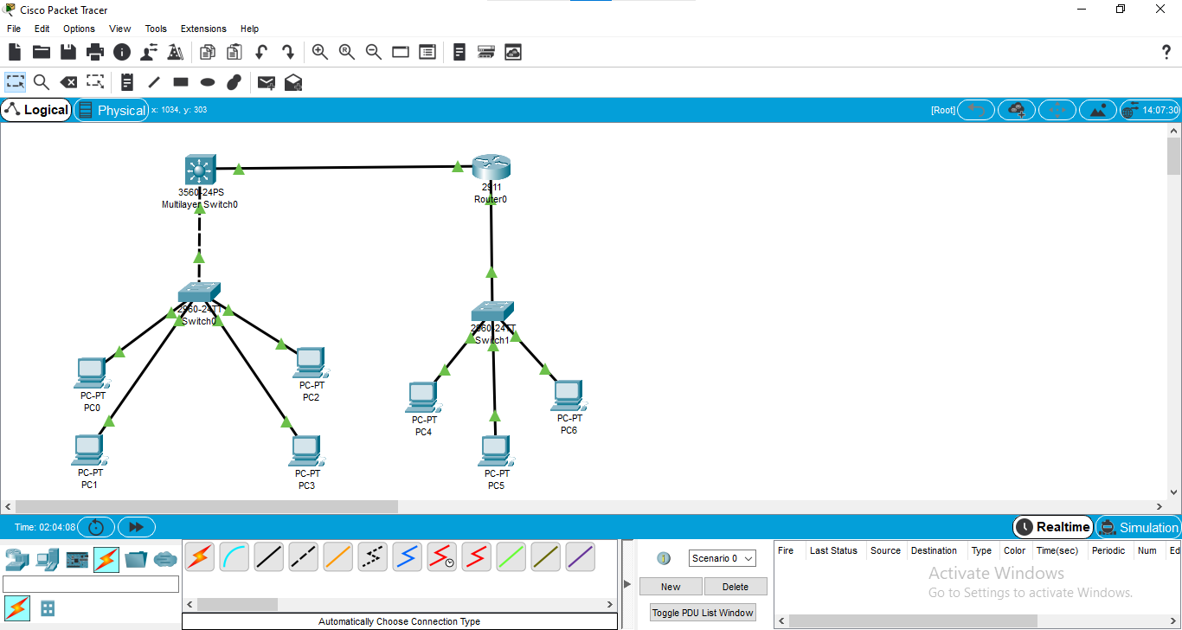

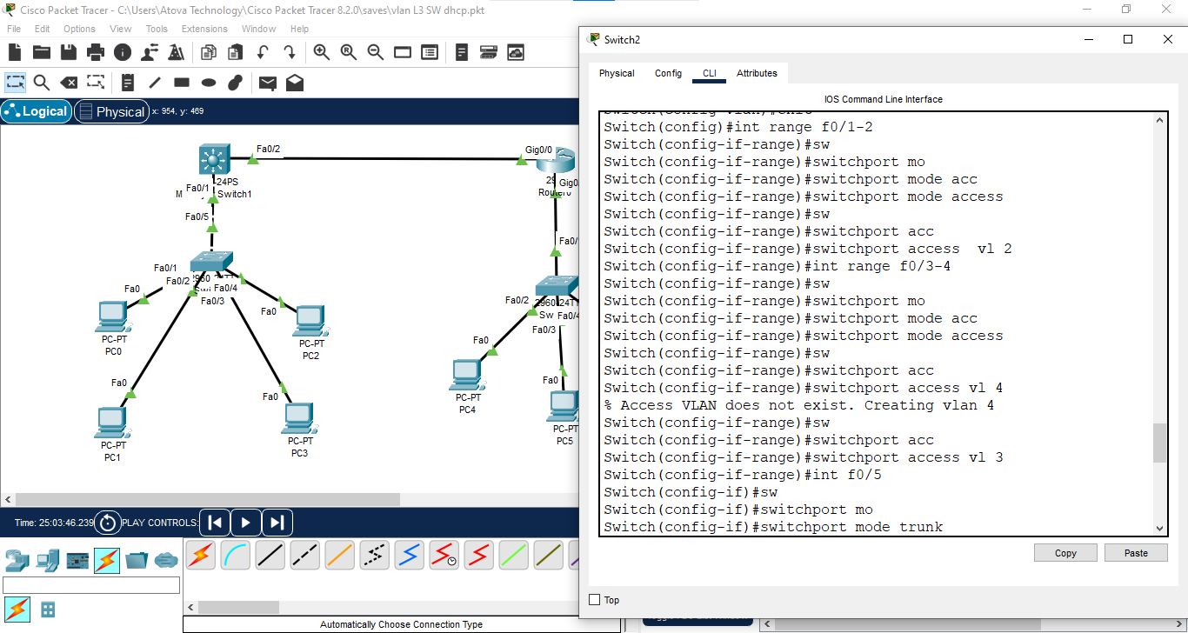

===========================================

L2 Switch

=========

Switch>

Switch>enable

Switch#conf t

Switch(config)#vlan 2

Switch(config-vlan)#vlan 3

Switch(config-vlan)#exit

Switch(config)#interface range f0/1-2

Switch(config-if-range)#switchport mode access

Switch(config-if-range)#switchport access vlan 2

Switch(config-if-range)#interface range f0/3-4

Switch(config-if-range)#switchport mode access

Switch(config-if-range)#switchport access vlan 3

Switch(config-if-range)#int f0/5

Switch(config-if)#switchport mode trunk

===========================================

L3 Switch

=========

Switch>

Switch>enable

Switch#conf t

Switch(config)#vl 2

Switch(config-vlan)#vl 3

Switch(config-vlan)#exit

Switch(config)#ip routing

Switch(config)#interface vlan 2

Switch(config-if)#ip address 192.168.10.1 255.255.255.0

Switch(config-if)#interface vlan 3

Switch(config-if)#ip address 192.168.20.1 255.255.255.0

Switch(config-if)#int f0/1

Switch(config-if)#switchport trunk encapsulation dot1q

Switch(config-if)#switchport mode trunk

Switch(config-if)#int f0/2

Switch(config-if)#no switchport

Switch(config-if)#ip address 172.16.10.1 255.255.255.252

Switch(config-if)#exit

Switch(config)#

Switch(config)#router rip

Switch(config-router)#version 2

Switch(config-router)#network 192.168.10.0

Switch(config-router)#network 192.168.20.0

Switch(config-router)#network 172.16.10.0

===============================================

Router

======

Router>

Router>enable

Router#conf t

Router(config)#int g0/0/0

Router(config-if)#no shutdown

Router(config-if)#ip address 172.16.10.2 255.255.255.252

Router(config-if)#int g0/0/1

Router(config-if)#no shutdown

Router(config-if)#ip address 192.168.200.1 255.255.255.0

Router(config-if)#exit

Router(config)#ip dhcp pool atova

Router(dhcp-config)#default-router 192.168.200.1

Router(dhcp-config)#dns-server 8.8.8.8

Router(dhcp-config)#domain-name atovatech.com

Router(dhcp-config)#network 192.168.200.0 255.255.255.0

Router(dhcp-config)#exit

Router(config)#ip dhcp excluded-address 192.168.200.200 192.168.200.254

Router(config)#router rip

Router(config-router)#version 2

Router(config-router)#network 192.168.200.0

Router(config-router)#network 172.16.10.0

Router(config-router)#^Z

Router#sh ip route

**2.VLAN:**

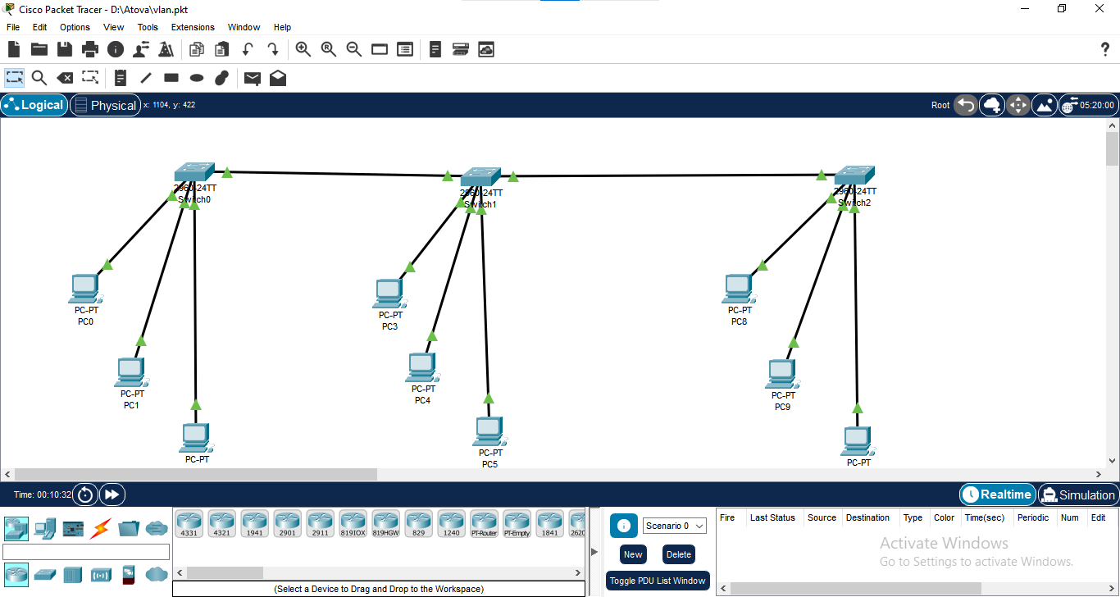

Switch>

Switch>enable

Switch#conf t

Switch(config)#hostname SW-1

SW-1(config)#exit

SW-1#sh vlan

SW-1#conf t

SW-1(config)#vlan 2

SW-1(config-vlan)#name sales

SW-1(config-vlan)#vlan 3

SW-1(config-vlan)#name marketing

SW-1(config-vlan)#vlan 4

SW-1(config-vlan)#name finance

SW-1(config-vlan)#end

SW-1#sh vlan

SW-1#conf t

SW-1(config)#int f0/1

SW-1(config-if)#switchport mode access

SW-1(config-if)#switchport access vlan 2

SW-1(config-if)#int f0/2

SW-1(config-if)#switchport mode access

SW-1(config-if)#switchport access vlan 3

SW-1(config-if)#int f0/3

SW-1(config-if)#switchport mode access

SW-1(config-if)#switchport access vlan 4

SW-1(config-if)#

SW-1(config-if)#int f0/4

SW-1(config-if)#switchport mode trunk

==============================================

Switch>

Switch>enable

Switch#conf t

Switch(config)#hostname SW-2

SW-2(config)#vlan 2

SW-2(config-vlan)#name sales

SW-2(config-vlan)#vlan 3

SW-2(config-vlan)#name marketing

SW-2(config-vlan)#vlan 4

SW-2(config-vlan)#name finance

SW-2(config-vlan)#int f0/1

SW-2(config-if)#switchport mode access

SW-2(config-if)#switchport access vlan 2

SW-2(config-if)#int f0/2

SW-2(config-if)#switchport mode access

SW-2(config-if)#switchport access vlan 3

SW-2(config-if)#int f0/3

SW-2(config-if)#switchport mode access

SW-2(config-if)#switchport access vlan 4

SW-2(config-if)#int f0/4

SW-2(config-if)#switchport mode trunk

================================================

Switch>

Switch>enable

Switch#conf t

Switch(config)#hostname SW-3

SW-3(config)#vlan 2

SW-3(config-vlan)#name sales

SW-3(config-vlan)#vlan 3

SW-3(config-vlan)#name marketing

SW-3(config-vlan)#vlan 4

SW-3(config-vlan)#name finance

SW-3(config-vlan)#int f0/1

SW-3(config-if)#switchport mode access

SW-3(config-if)#switchport access vlan 2

SW-3(config-if)#int f0/2

SW-3(config-if)#switchport mode access

SW-3(config-if)#switchport access vlan 3

SW-3(config-if)#int f0/3

SW-3(config-if)#switchport mode access

SW-3(config-if)#switchport access vlan 4

SW-3(config-if)#end

SW-3#sh vlan

SW-3#conf t

SW-3(config)#int f0/4

SW-3(config-if)#switchport mode trunk

SW-3(config-if)#

**VTP mood:**

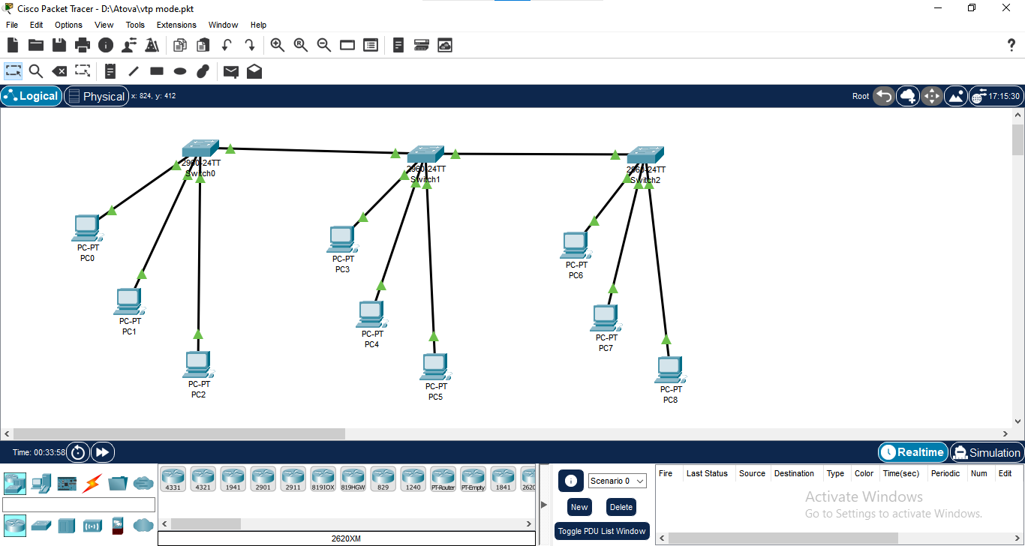

Switch>

Switch>enable

Switch#conf t

Switch(config)#int f0/4

Switch(config-if)#switchport mode trunk

Switch(config-if)#exit

Switch(config)#vtp mode server

Switch(config)#vtp domain cisco

Switch(config)#vtp password 123

Switch(config)#vlan 2

Switch(config-vlan)#name sales

Switch(config-vlan)#vlan 20

Switch(config-vlan)#name marketing

Switch(config-vlan)#vlan 30

Switch(config-vlan)#name IT

Switch(config-vlan)#end

Switch#sh vlan

=====================================

Switch>

Switch>enable

Switch#conf t

Switch(config)#int f0/4

Switch(config-if)#switchport mode trunk

Switch(config)#int f0/5

Switch(config-if)#switchport mode trunk

Switch(config-if)#exit

Switch(config)#vtp mode client

Switch(config)#vtp domain cisco

Switch(config)#vtp password 123

Switch(config)#end

Switch#sh vlan

**3.Static_routing:**

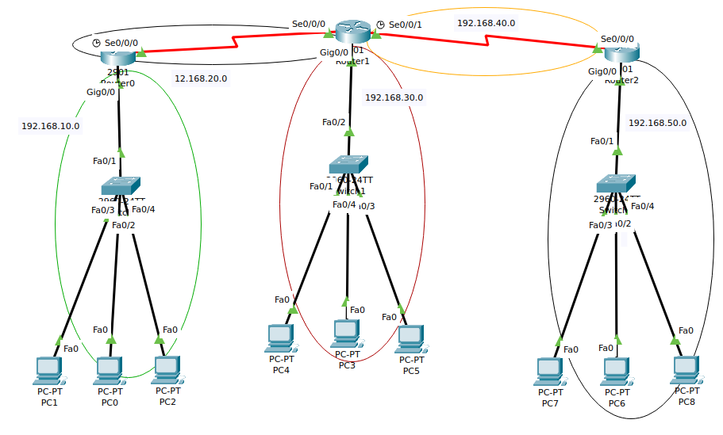

Route_1

======

Router>

Router>enable

Router#conf t

Router(config)#int g0/0

Router(config-if)#no shutdown

Router(config-if)#ip address 192.168.10.1 255.255.255.0

Router(config-if)#int s0/0/0

Router(config-if)#no shutdown

Router(config-if)#ip address 192.168.20.1 255.255.255.0

Router(config-if)#exit

Router(config)#ip route 192.168.30.0 255.255.255.0 192.168.20.2

Router(config)#ip route 192.168.40.0 255.255.255.0 192.168.20.2

Router(config)#ip route 192.168.50.0 255.255.255.0 192.168.20.2

Router_2

=======

Router>

Router>enable

Router#conf t

Router(config)#int s0/0/0

Router(config-if)#no shutdown

Router(config-if)#ip address 192.168.20.2 255.255.255.0

Router(config-if)#int s0/0/1

Router(config-if)#no shutdown

Router(config-if)#ip address 192.168.40.1 255.255.255.0

Router(config-if)#int g0/0

Router(config-if)#no shutdown

Router(config-if)#ip address 192.168.30.1 255.255.255.0

Router(config-if)#exit

Router(config)#ip route 192.168.10.0 255.255.255.0 192.168.20.1

Router(config)#ip route 192.168.50.0 255.255.255.0 192.168.40.2

Router_3

=======

Router>

Router>enable

Router#conf t

Router(config)#int s0/0/0

Router(config-if)#no shutdown

Router(config-if)#ip address 192.168.40.2 255.255.2

Router(config-if)#int g0/0

Router(config-if)#no shutdown

Router(config-if)#ip address 192.168.50.1 255.255.255.0

Router(config-if)#exit

Router(config)#ip route 192.168.30.0 255.255.255.0 192.168.40.1

Router(config)#ip route 192.168.20.0 255.255.255.0 192.168.40.1

Router(config)#ip route 192.168.10.0 255.255.255.0 192.168.40.1

Router(config)#end

Router#sh ip route

**4.HSRP-(Hot Standby Router Protocol):**

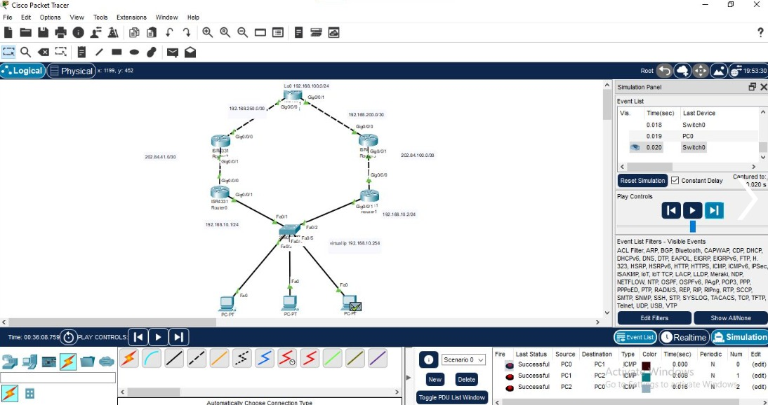

LocalRouter-1

===========

Router>

Router>enable

Router#conf t

Router(config)#

Router(config)#int g0/0/1

Router(config-if)#no shutdown

Router(config-if)#ip address 202.84.41.1 255.255.255.252

Router(config-if)#int g0/0/0

Router(config-if)#no shutdown

Router(config-if)#ip address 192.168.10.1 255.255.255.0

Router(config-if)#exit

Router(config)#router rip

Router(config-router)#version 2

Router(config-router)#network 192.168.10.0

Router(config-router)#network 202.84.41.0

Router(config-router)#int g0/0/0

Router(config-if)#standby 1 ip 192.168.10.254

Router(config-if)#standby 1 priority 200

Router(config-if)#standby 1 preempt

Router(config-if)#exit

Router#sh standby

========================

LocalRouter-2

===========

Router>

Router>enable

Router#conf t

Router(config)#

Router(config)#int g0/0/1

Router(config-if)#no shutdown

Router(config-if)#ip address 202.84.100.1 255.255.255.252

Router(config-if)#int g0/0/0

Router(config-if)#no shutdown

Router(config-if)#ip address 192.168.10.2 255.255.255.0

Router(config-if)#exit

Router(config)#router rip

Router(config-router)#version 2

Router(config-router)#network 192.168.10.0

Router(config-router)#network 202.84.100.0

Router(config-router)#int g0/0/0

Router(config-if)#standby 1 ip 192.168.10.254

Router(config-if)#standby 1 priority 200

Router(config-if)#standby 1 preempt

Router(config-if)#exit

Router#sh standby

========================

ISP-1

====

Router>

Router>enable

Router#conf t

Router(config)#int g0/0/0

Router(config-if)#no shutdown

Router(config-if)#ip address 202.84.41.2 255.255.255.252

Router(config-if)#int g0/0/1

Router(config-if)#no shutdown

Router(config-if)#ip address 192.168.250.1 255.255.255.252

Router(config-if)#exit

Router(config)#router rip

Router(config-router)#version 2

Router(config-router)#network 192.168.250.0

Router(config-router)#network 202.84.41.0

===================================

ISP-2

====

Router>

Router>enable

Router#conf t

Router(config)#int g0/0/0

Router(config-if)#no shutdown

Router(config-if)#ip address 202.84.100.2 255.255.255.252

Router(config-if)#int g0/0/1

Router(config-if)#no shutdown

Router(config-if)#ip address 192.168.200.1 255.255.255.252

Router(config-if)#exit

Router(config)#router rip

Router(config-router)#version 2

Router(config-router)#network 202.84.100.0

Router(config-router)#network 192.168.200.0

==========================================

IIG

===

Router>

Router>enable

Router#conf t

Router(config)#int g0/0/0

Router(config-if)#no shutdown

Router(config-if)#ip address 192.168.250.2 255.255.255.252

Router(config-if)#int g0/0/1

Router(config-if)#no shutdown

Router(config-if)#ip address 192.168.200.2 255.255.255.252

Router(config-if)#int lo0

Router(config-if)#ip address 192.168.100.1 255.255.255.0

Router(config-if)#exit

Router(config)#router rip

Router(config-router)#version 2

Router(config-router)#network 192.168.100.0

Router(config-router)#network 192.168.200.0

Router(config-router)#network 192.168.250.0

Router(config-router)#exit

Router#sh ip int brief

**Accesspoint: cisco wireless architecture**

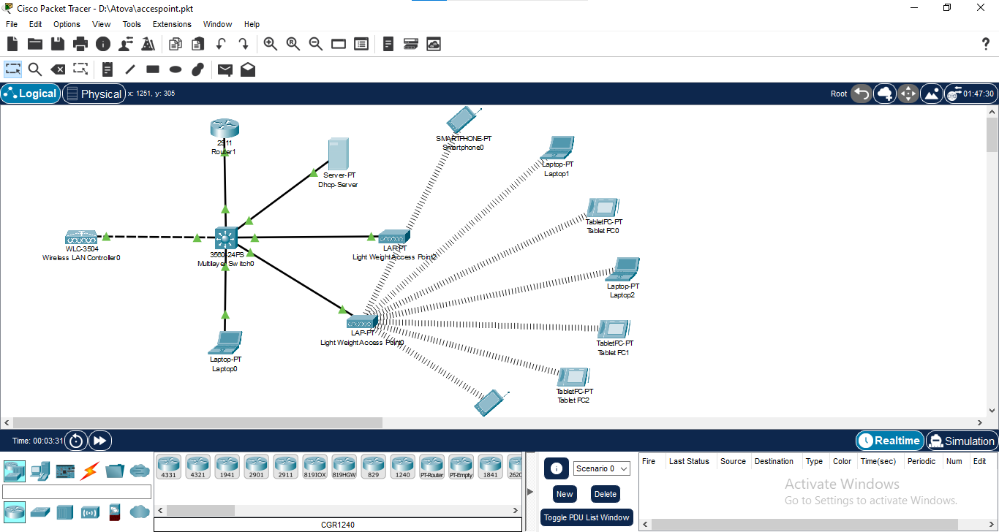

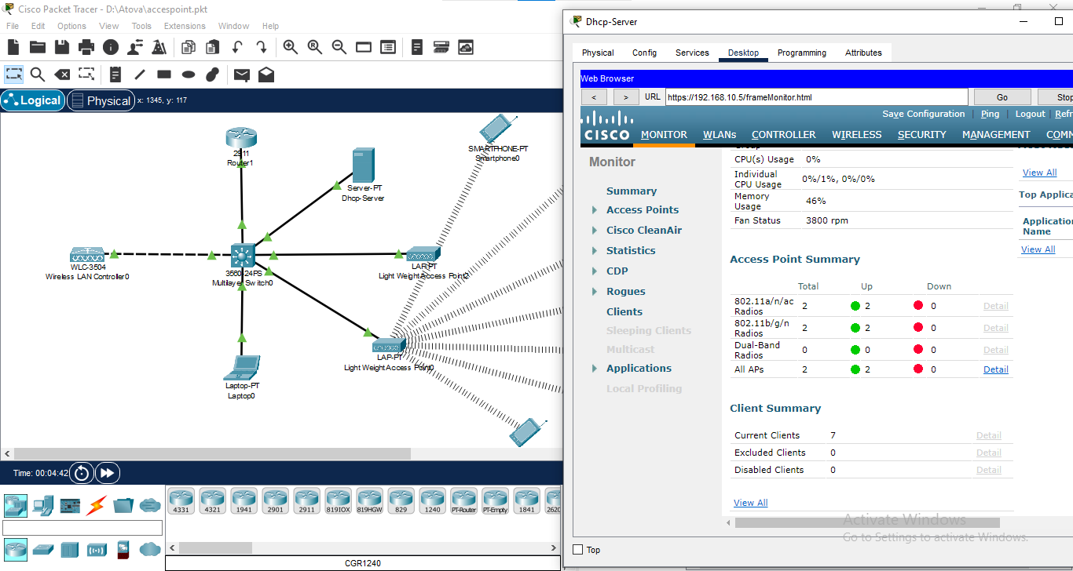

**Conclusion**

The industrial training in CCNA has been an invaluable experience, providing me with practical skills and knowledge in the field of networking. I am confident that the expertise gained during this training program will be instrumental in my future endeavors within the networking industry. I am sincerely grateful to [Company Name] for their support and guidance throughout this training, which has significantly contributed to my professional development.